

**CUSTOMER RETENTION**

**DATASET**

**Submitted by:**

**MD.THAYAB NAWAZ**

**ACKNOWLEDGMENT**

**I would like to thank Flip Robo Technologies for providing me with the opportunity to work on this project from which I have learned a lot. I am also grateful to Swati Mahaseth for his constant guidance and support.**

**CONTENTS**

**1. What is Customer Retention?**

**2. Why is customer retention important?**

**3. Customer retention benefits.**

**4. Review of Literature**

**INTRODUCTION**

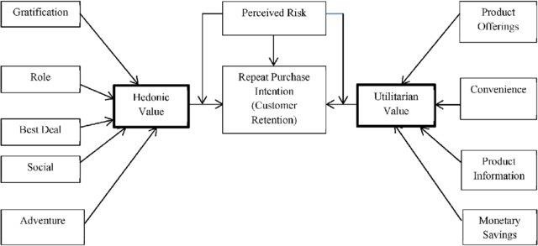**Customer Retention refers to the action and strategies a business uses to try and keep existing customers. To enable these actions, customer retention analytics provide predictive metrics of which customer might churn-which enable them to get ahead of it. Customer satisfaction has emerged as one of the most important factors that guarantee the success of online store; it has been posited as a key stimulant of purchase, repurchase intentions and customer loyalty. A comprehensive review of the literature, theories and models have been carried out to propose the models for customer activation and customer retention. Five major factors that contributed to the success of an e-commerce store have been identified as: service quality, system quality, information quality, trust and net benefit. The research furthermore investigated the factors that influence the online customers repeat purchase intention. The combination of both utilitarian value and hedonistic values are needed to affect the repeat purchase intention (loyalty) positively. The data is collected from the Indian online shoppers. Results indicate the e-retail success factors, which are very much critical for customer satisfaction.**

**1. What is Customer Retention?**

**Customer Retention refers to a company’s ability to turn customers into repeat buyers and prevent them from switching to a competitor. It indicates whether your product and the quality of the service please your existing customers. 3 Customer Retention strategies are the processes and initiatives businesses put in place to build customer loyalty and improve customer lifetime value.**

**2. Why is customer retention important?**

**Customer retention increases your customers’ lifetime value and boosts your revenue. It also helps you build amazing relationship with your customers. You aren’t just another website or store. They trust you with their money because you give them value in exchange. According to the Harvard Business Review, acquiring a new customer can be 5 to 25 times more expensive than holding on to an existing one. You don’t need to spend big on marketing, advertising or sales outreach. It is easier to turn existing customers into repeating ones, since they already trust your brand from previous purchases. New customers, however, often require more convincing when it comes to the initial sale.**

**3. Customer Retention benefits:**

**• Retention is Cheaper than Acquisition**

**• Loyal Customers are more profitable.**

**• Your Brand will stand out from the crowd.**

**• Engage customers provide more feedback.**

**• Loyal customers are more forgiving.**

**• Customers will explore your brand**

**REVIEW OF LITERATURE**

**Customer satisfaction has emerged as one of the most important factors that guarantee the success of online store; it has been posited as a key stimulant of purchase, repurchase intentions and customer loyalty. A comprehensive review of the literature, theories and models have been carried out to propose the models for customer activation and customer retention. Five major Factors that contributed to the success of an ecommerce store have been identified as service quality, system quality, information quality, trust and net benefit. The research furthermore investigated the factors that influence the online customers repeat purchase intention.**

**Purchase intention: Purchase intention can be characterized as the probability that an online client will purchase an item and keep on buying items from a similar online retailer. This essential develop "customers purchase choice” is clarified in the model regard to its relationship with another key factors.**

**User satisfaction: Satisfaction has been characterized as an individual sensation of happiness or delight, because of contrasting the genuine result of shopping on the web as against their assumption. Satisfaction of on the web customers will emphatically affect their future intention (repeat purchase) straightforwardly or by implication.**

**Net advantages: This is utilized to portray the absolute advantages of got when shopping online by customers, as against the expenses (for instance, exertion, cash and time). A portion of the net advantages got from web-based shopping include: money related increase, item search and purchasing adequacy, accommodation, ideal conveyance, happiness, wide item reach, and adaptability. Agreeing to an examination by Childers, net advantage of shopping online incorporates both utilitarian worth and gluttonous qualities.**

**Data quality: This can be characterized as the customers' insights towards the show also, qualities of data introduced or showed in an online business site, web application or gateway. It takes the qualities of data into thought, for instance, practicality, pertinence reasonable, exactness, and fulfilment. One of the essential obligations of an e-posterior is to guarantee the accessibility of complete data on items being offered, the value-based cycle included, and administrations to be delivered. Showing excellent data on the site can invigorate a further developed change rate too as better customers' satisfaction.**

**Framework quality: This can be portrayed as the users' impression of the online retail site's capacity to proficiently give mentioned data just as its conveyance strategy. Framework quality examinations the exhibition of the site; a portion of the measurement incorporates; page load speed, simplicity of route between pages, web architecture, appearance, site accessibility, and site format. Innovation acknowledgment model (TAM) states that, an e-retail site which is viewed as being not difficult to utilize is most liable to achieve a 5 sensation of energy among the shoppers. Szymanski furthermore, likewise believed that the exhibition of a site plays out a critical job in choosing satisfaction of the customers while shopping on the site. At the point when customers purchase an item from a site or web application, usefulness obstacles may bring about a helpless client user experience. Framework quality emphatically impacts online consumer loyalty. Administration quality Administration quality alludes to how well the administrations conveyed by an on the web retail location can coordinate with the assumptions for the client.**

**Analytical Problem Framing**

**The studies were identified using different keywords that are related mainly to customer retention and analysing other factors such as satisfaction, trust, and commitment in several searching processes until reaching a suitable number of related and targeted articles and studies to select and analyse. In the dataset there was no numerical columns and all the categorical columns has been analysed using all categorical plots to get better insight on the dataset. After visualizing the features it bought us a good insight that what actually customers are expecting from the e-commerce sellers.**

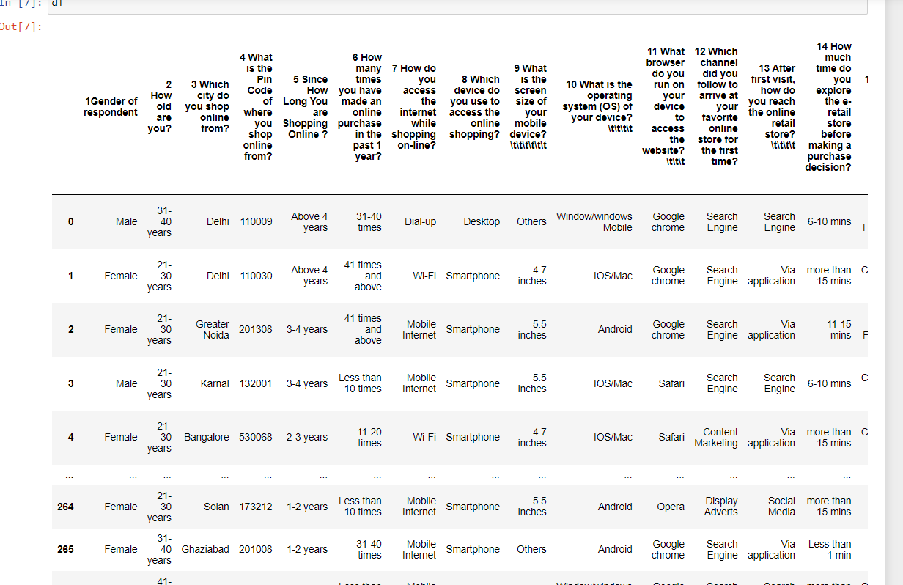

**Data:**

**In this project we are given excel file containing dataset of customer retention. There are 71 columns by which we can analyse how e-commerce sector can look after its customers to improve their service.**

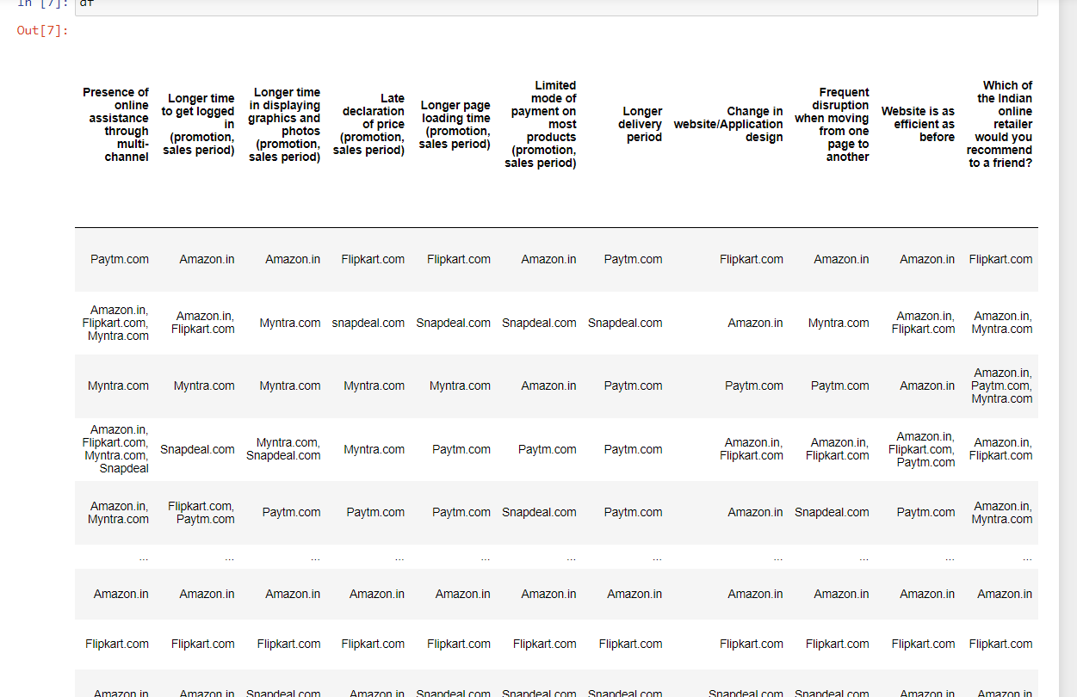

**All the variables in the dataset are of object type except pincode, however it is categorical in nature. The dataset contains 269 rows and 71 columns. The data contains no null value however there is a lot of unwanted characters in the columns.**

**Hardware and Software Requirements and Tools Used**

**• A mid level computer that runs on Intel i3- i5 8th generation, 4gb ram or A10/A11or any other equivalent chipset and a suitable processor.**

**• Juypter Notebook/Google chrome**

**• Libraries and packeges used:**

**import pandas as pd**

**import numpy as np**

**import matplotlib. pyplot as plt**

**import seaborn as sn**

**import warnings warnings.filterwarnings("ignore")**

**We will use Python through Jupyter notebook for data processing. Also we will use liabraries here is numpy, matplotlib, pandas and seaborn. The matpotplotlib and seaborn library has been used to make charts to visualize and understand the problem, correlation, outliers and many other things, the pandas and numpy library issued to handel dataset and perform various tasks.**

**Exploratory Data Analysis:**

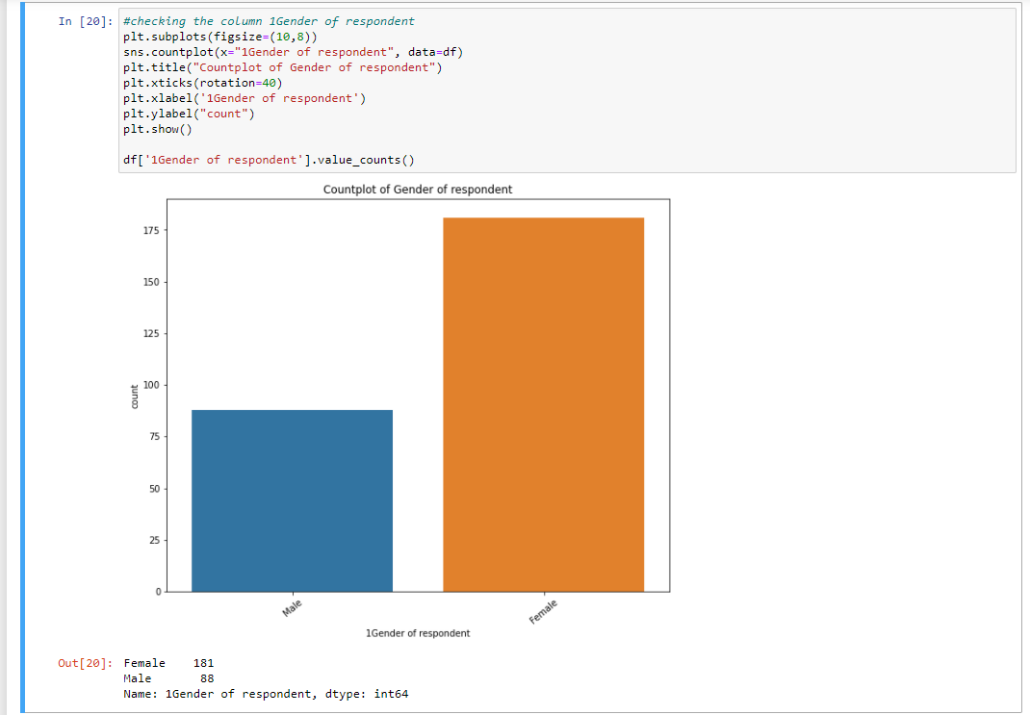

* **Majority, 181 of the customers are Female whereas Male are 88.**

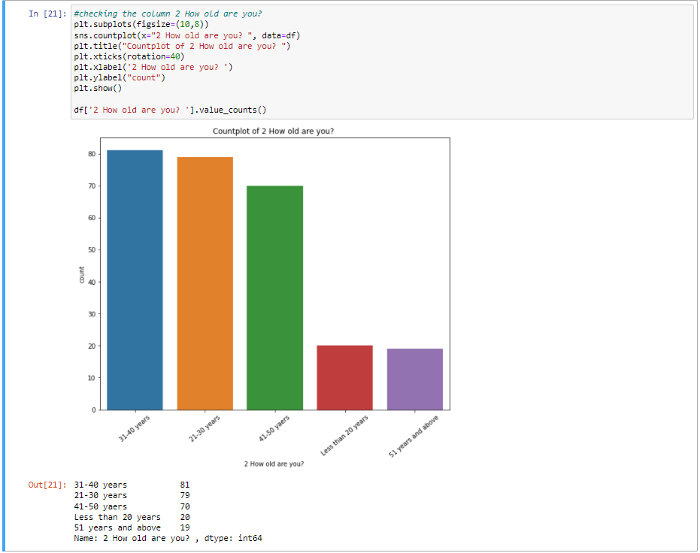

* **Majority, 81 of the customers are from age group 31-40 years.**

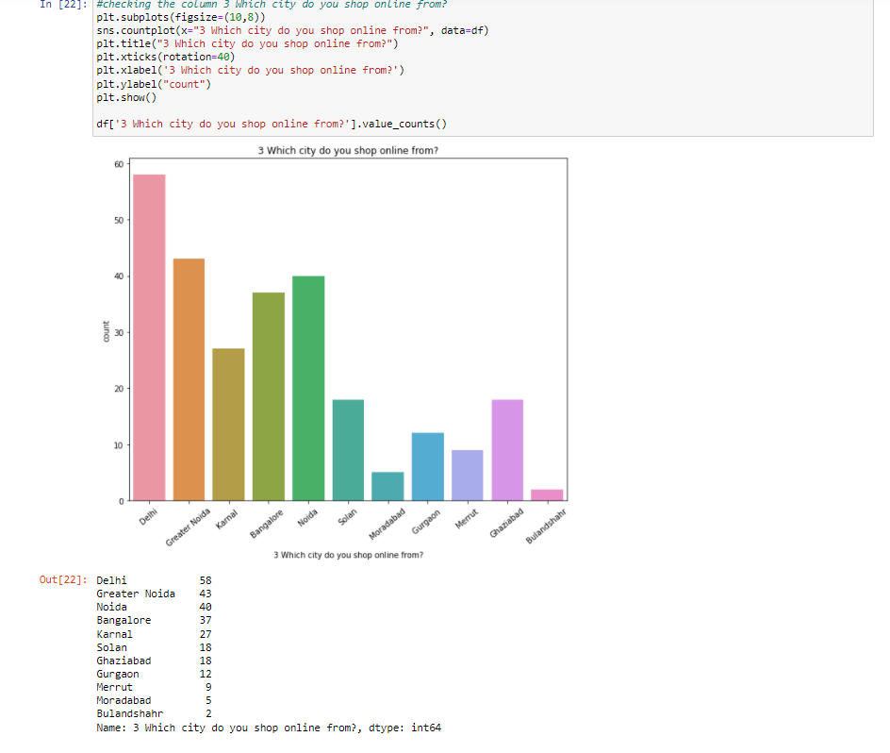

* **Majority, 58 of the customers placed the order at Delhi city.**

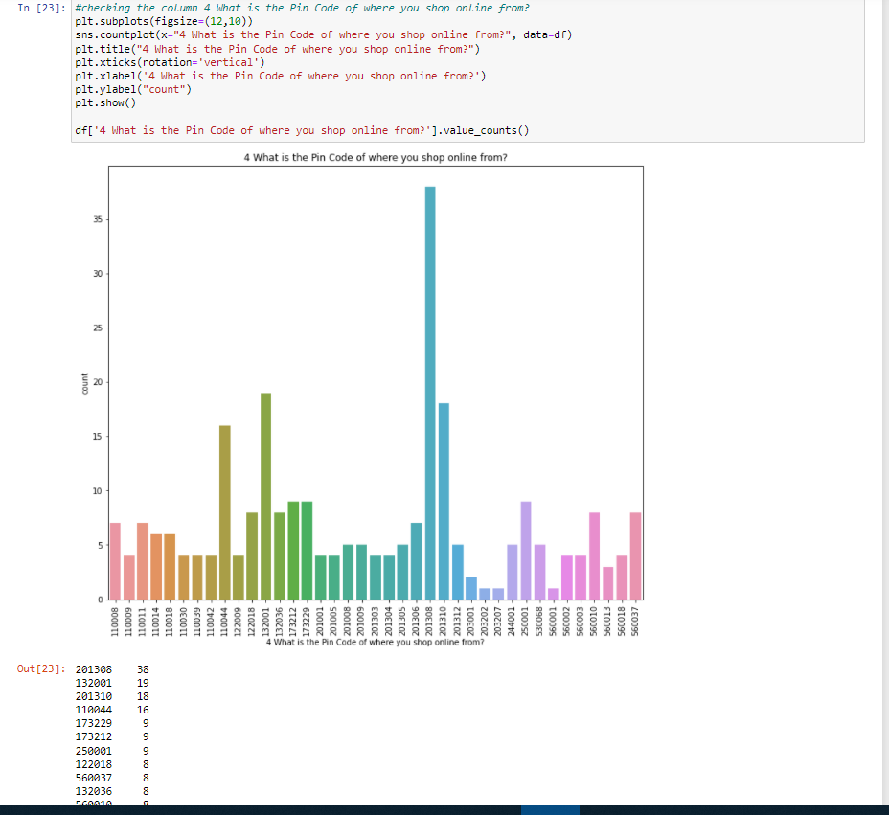

* **Majority, 38 of the customers placed an order from the pincode 201308.**

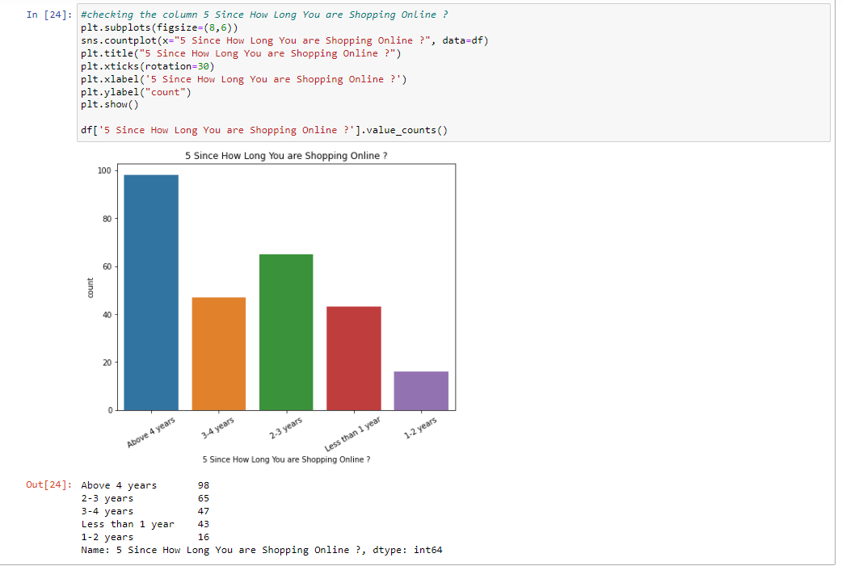

* **Majority, 98 customers are shopping since above 4 years.**

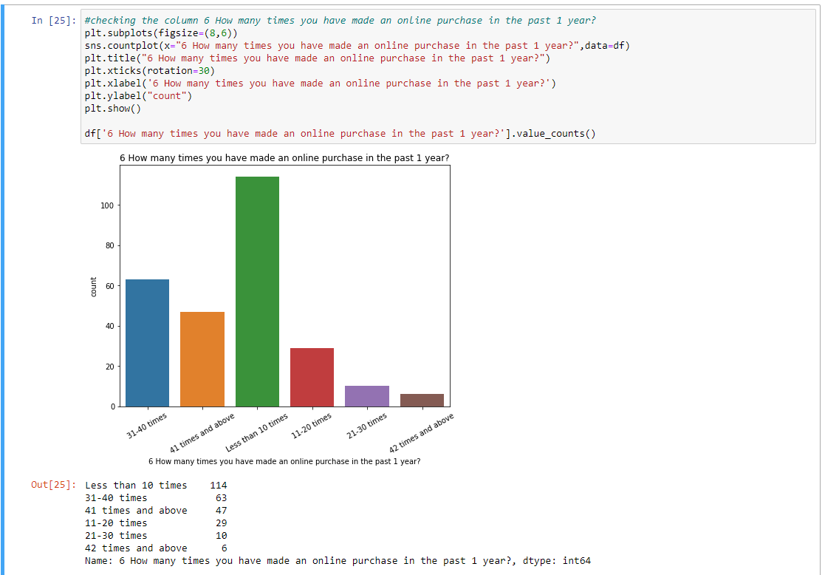

* **Majority 114 of the customers have made less than 10 times online purchase in the past 1 year.**

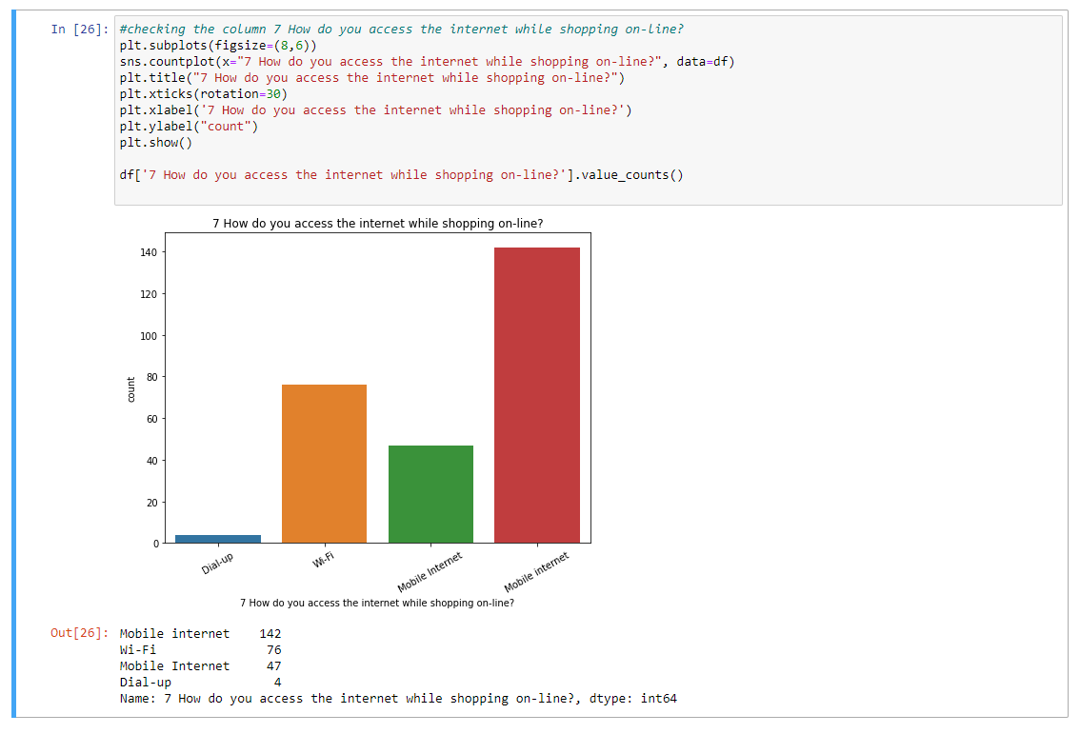

* **Majority, 189 customers use Mobile internet while shopping online.**

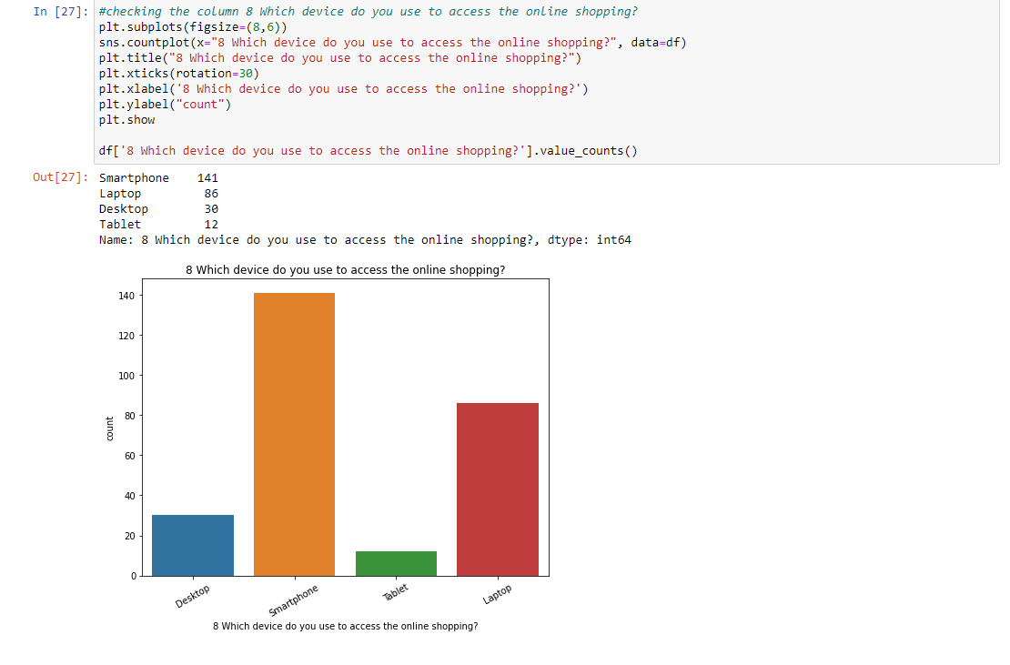

* **Majority, 141 customers smartphone while shopping online.**

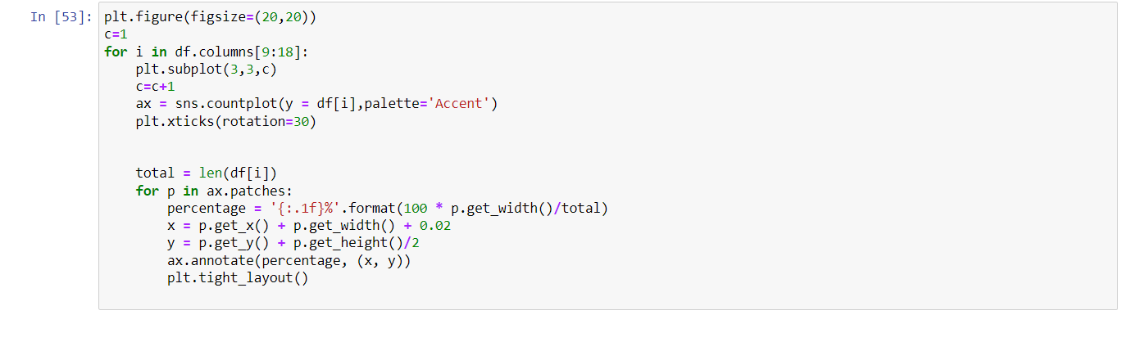 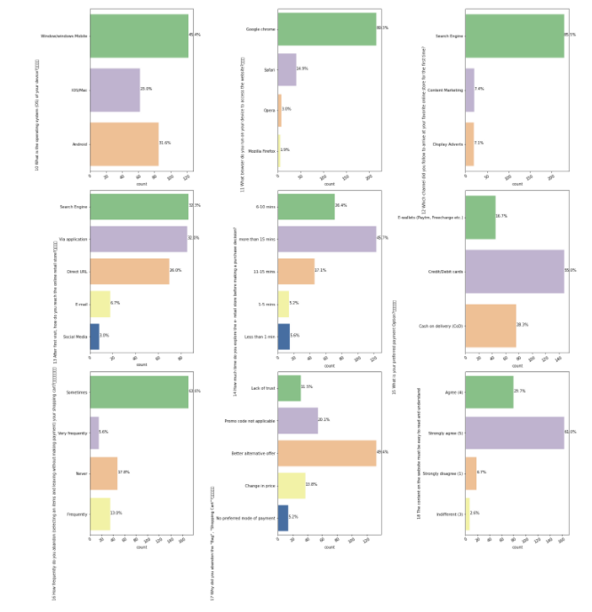

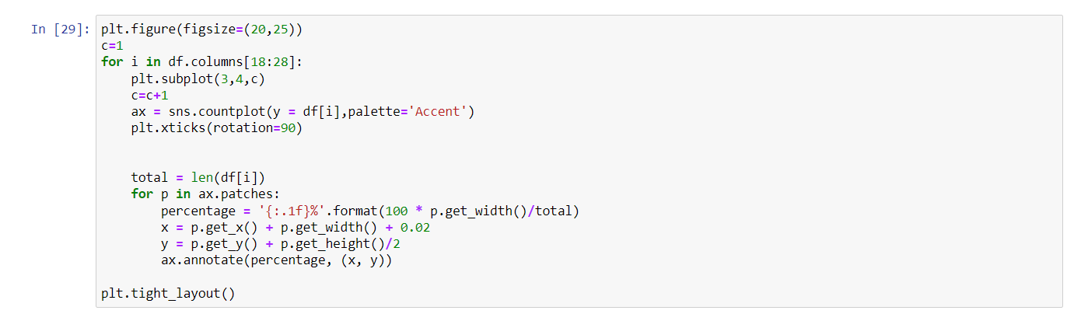 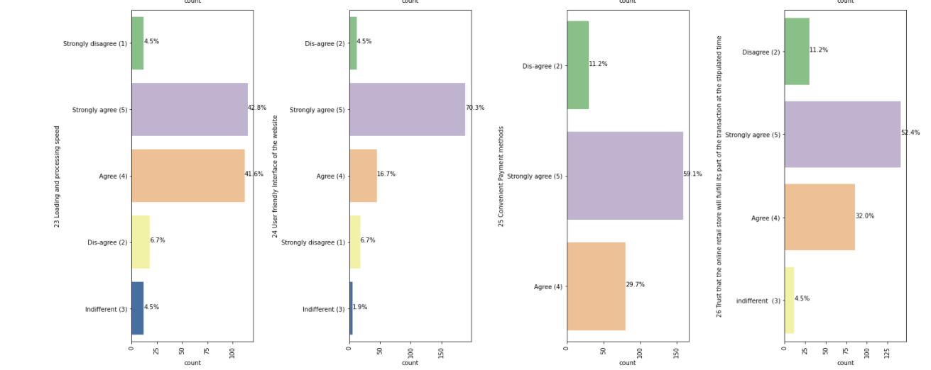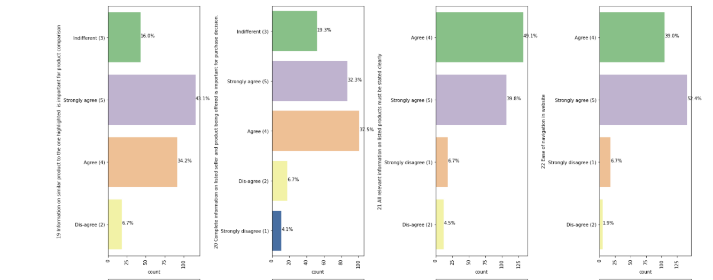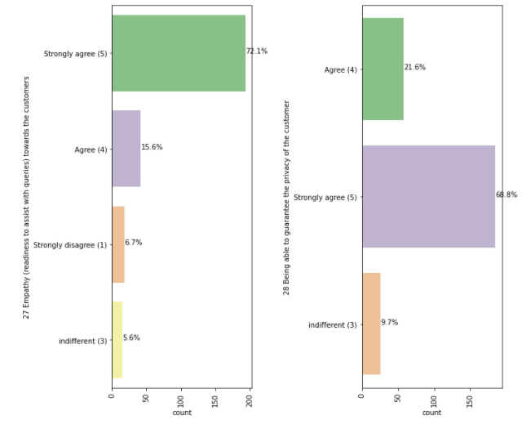

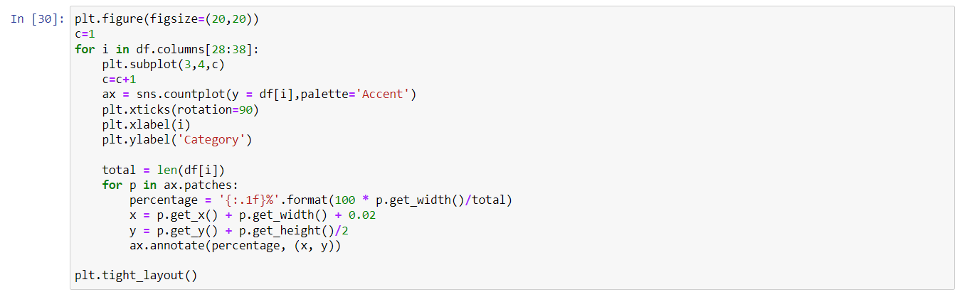 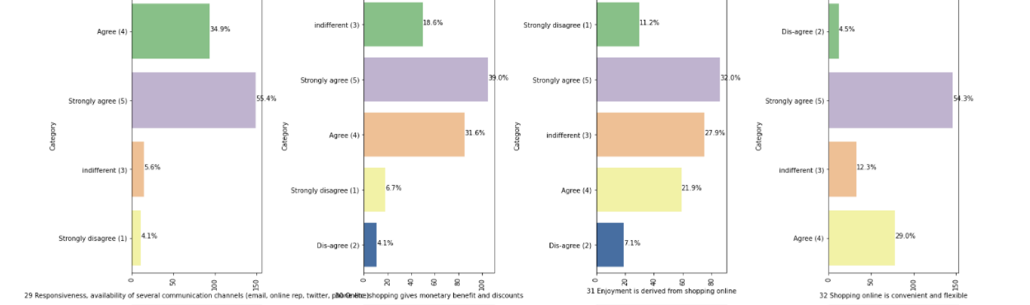

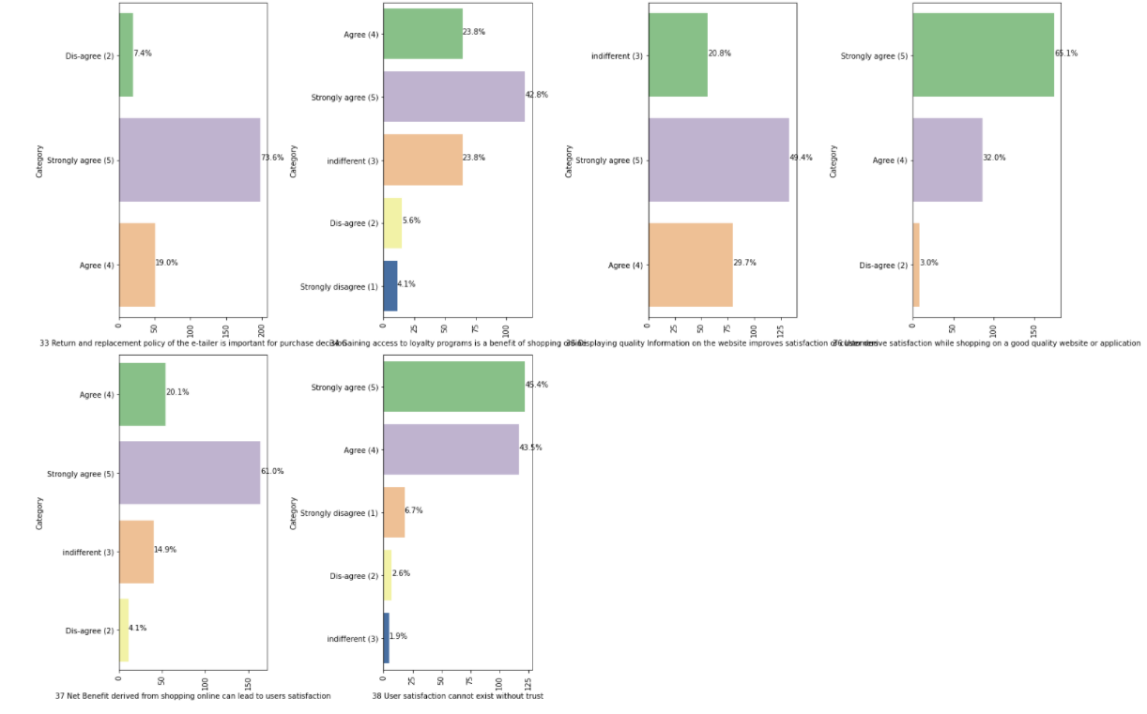

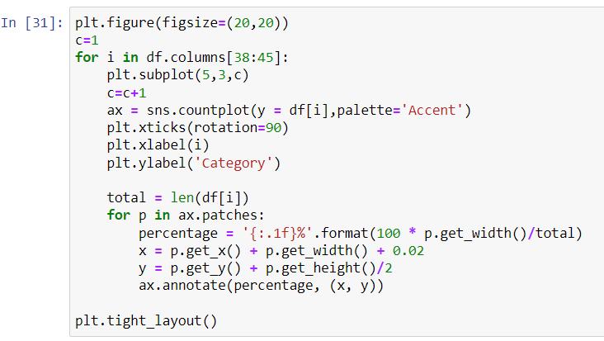

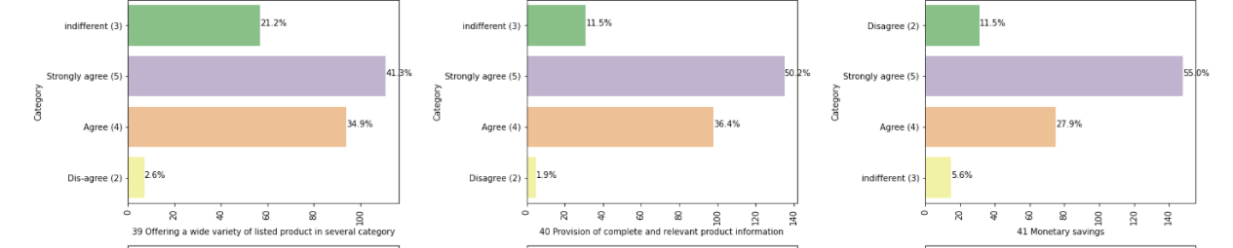

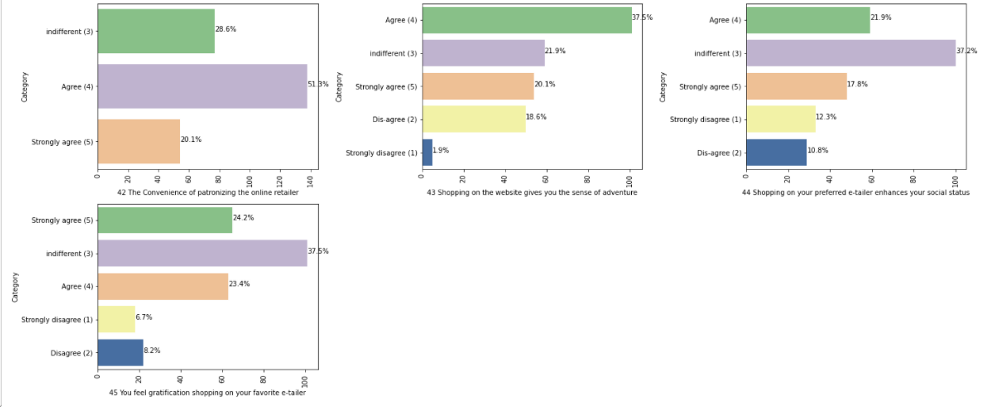

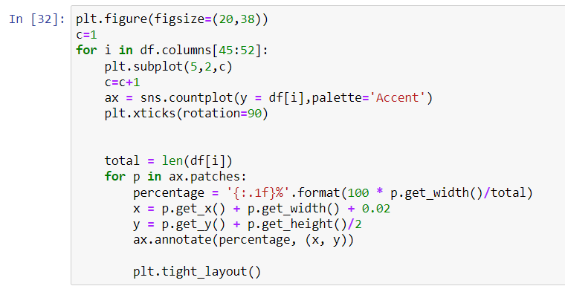 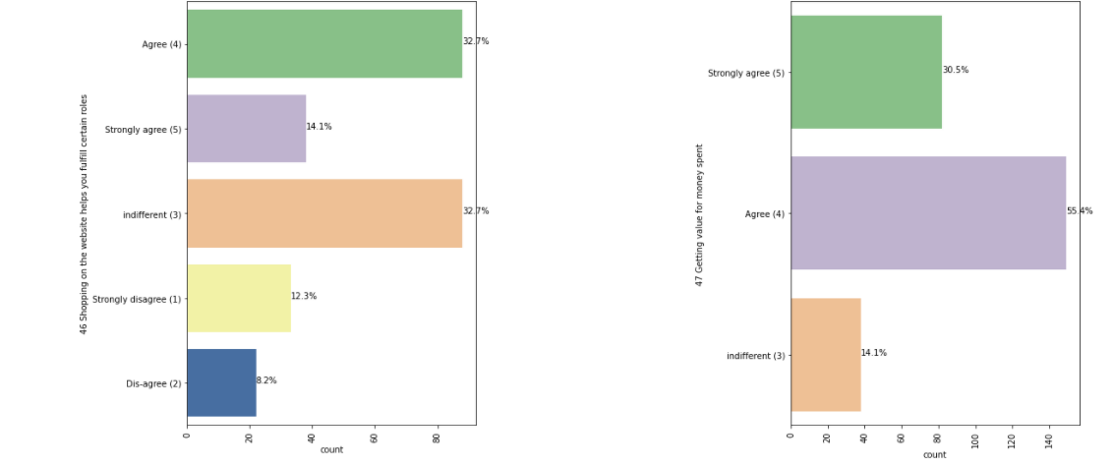 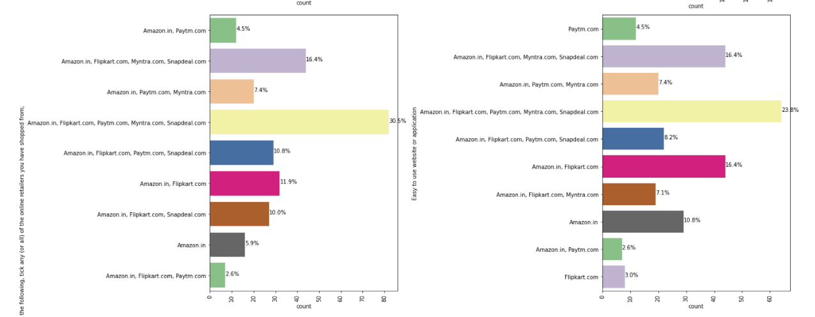

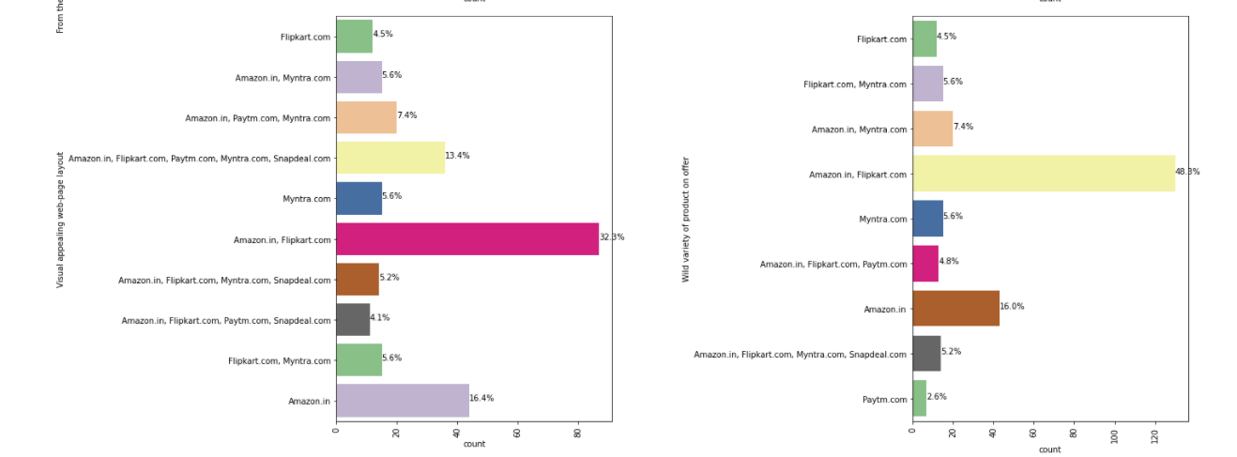

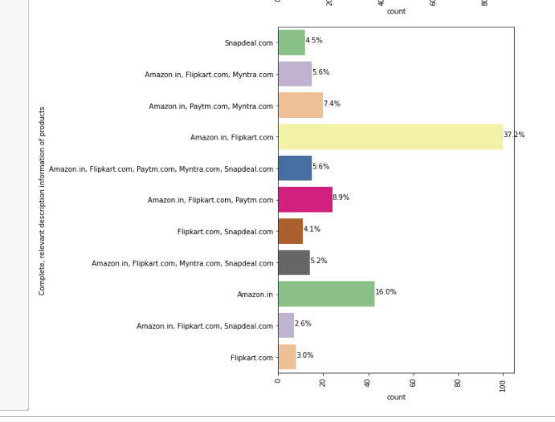

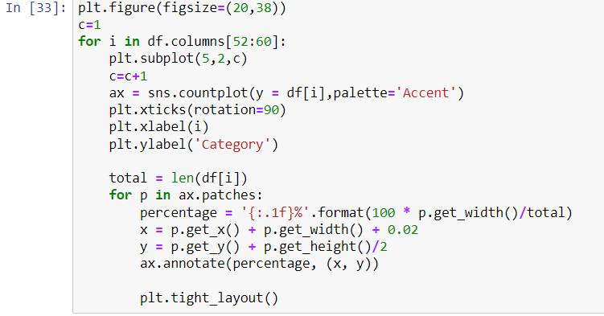

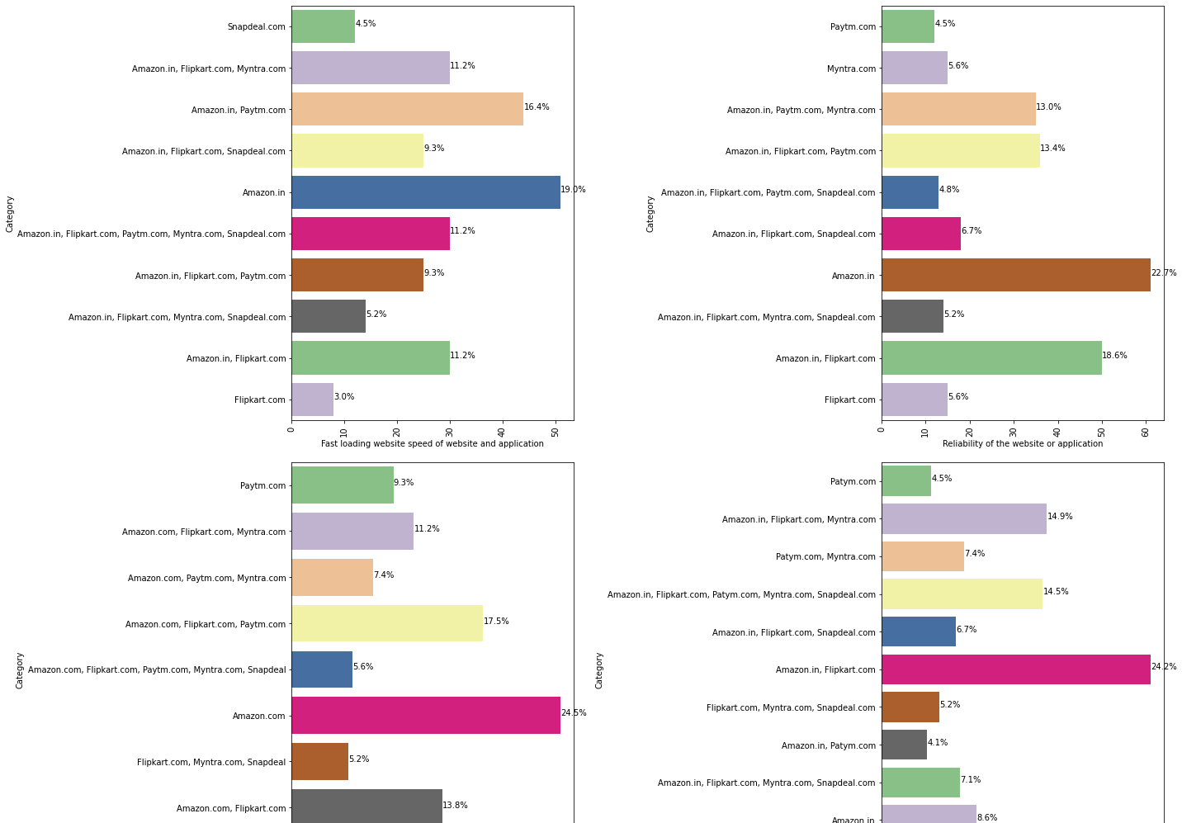

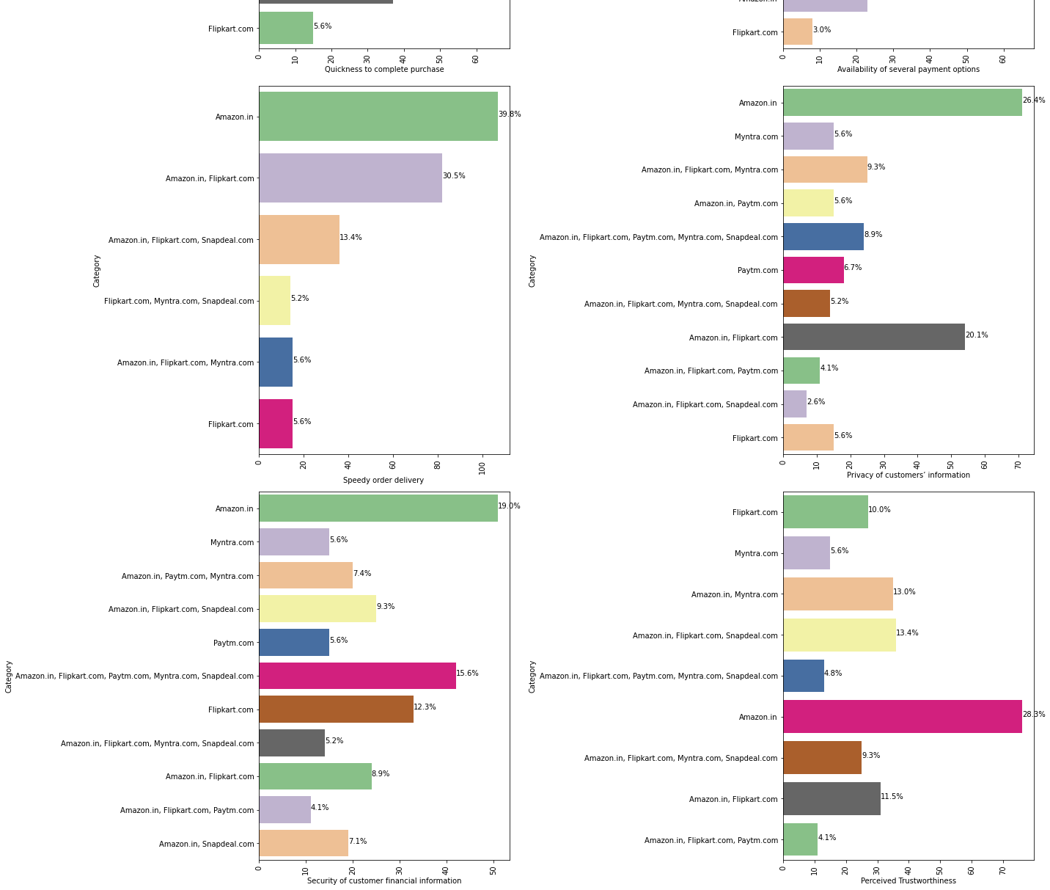

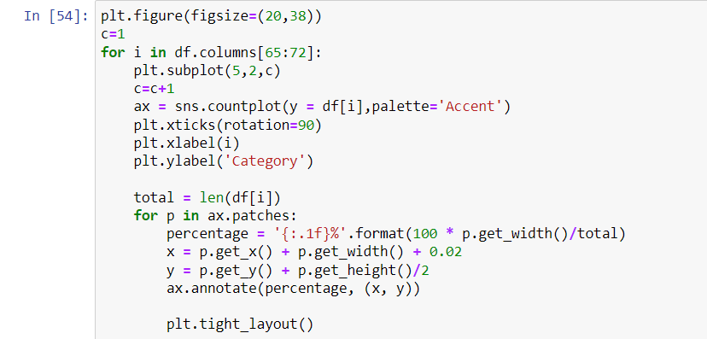

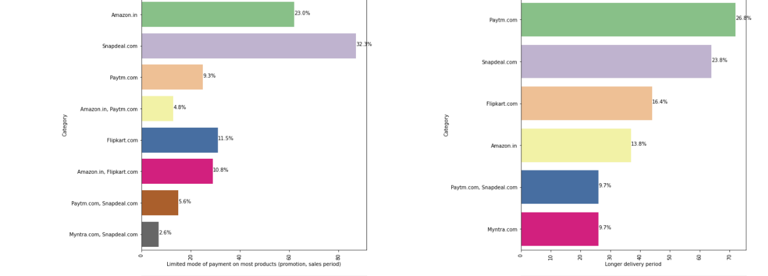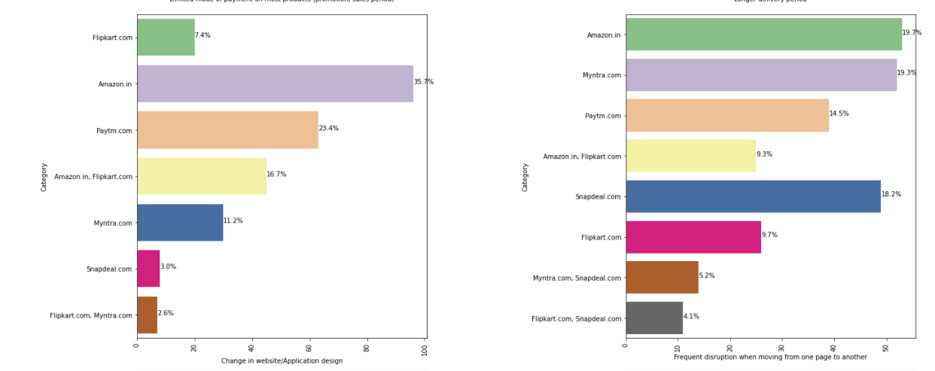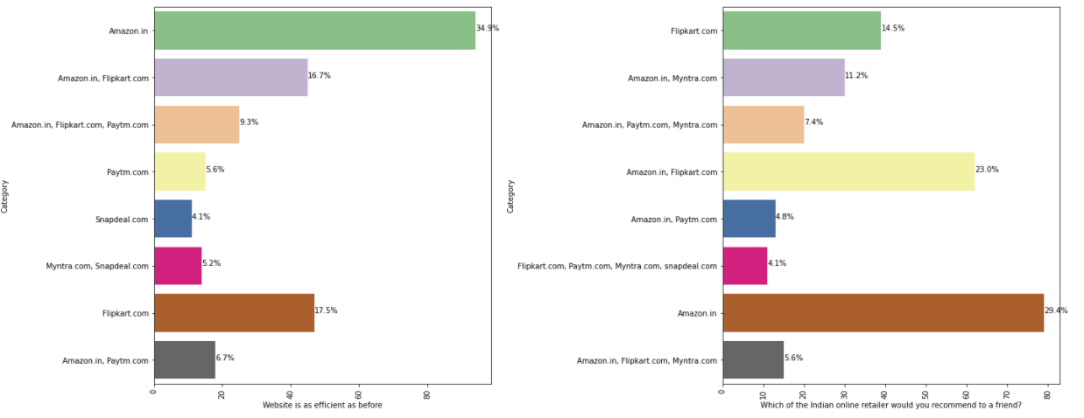

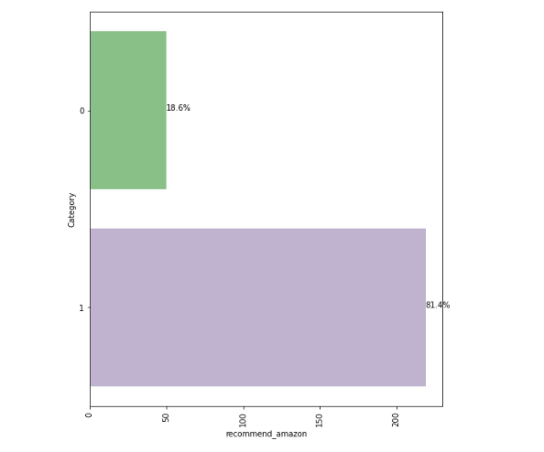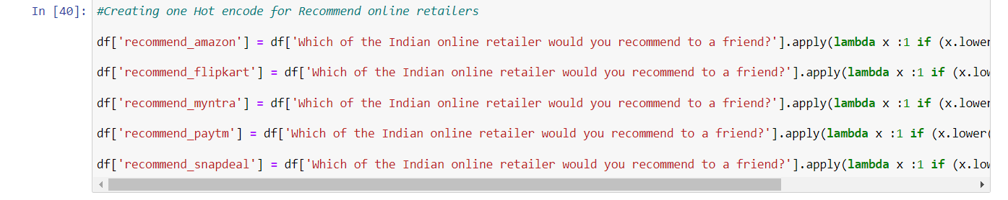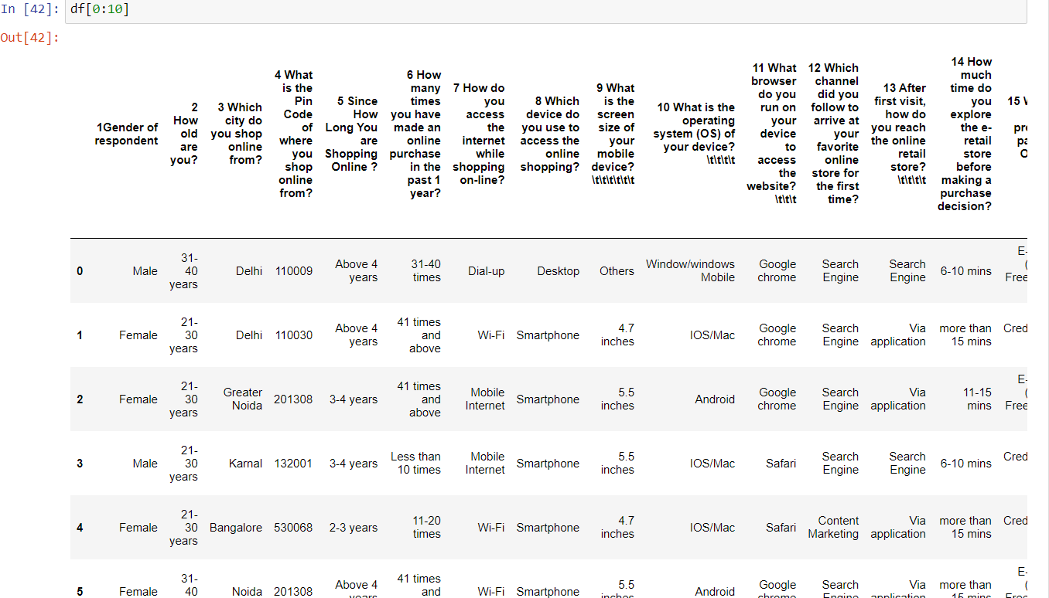

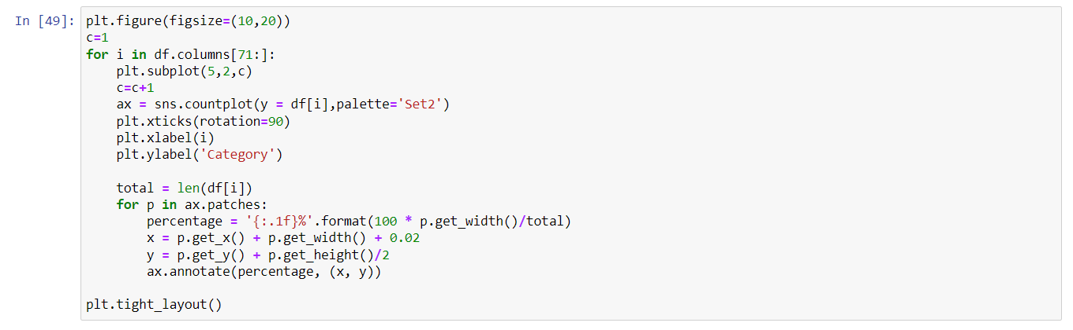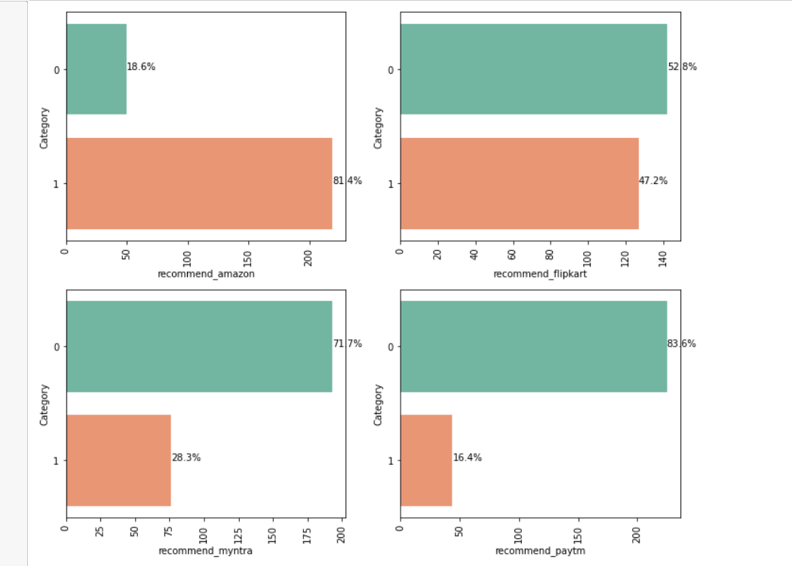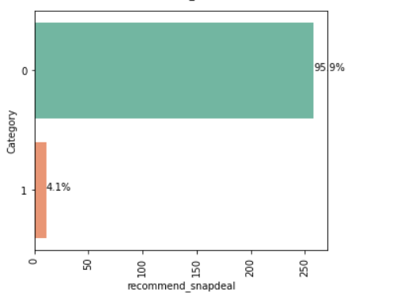

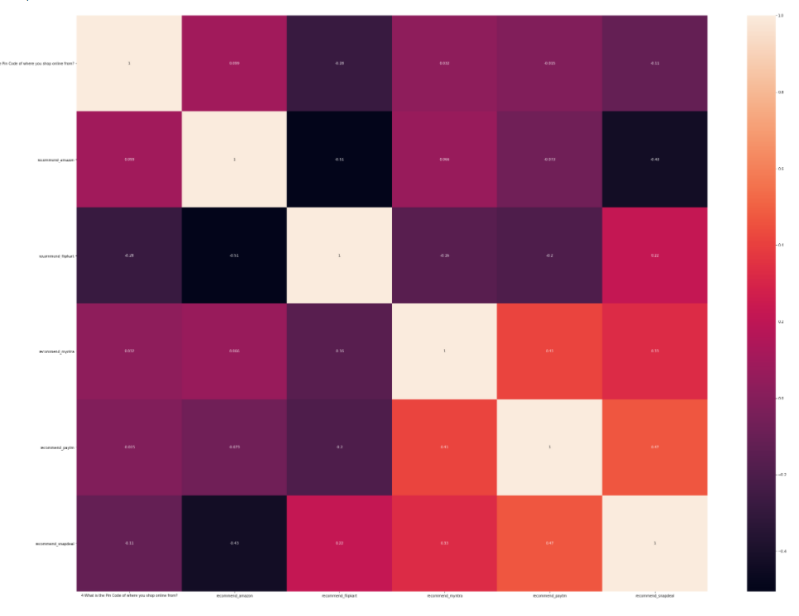

**CONCLUSION**

* **Amazon is recommended by 81.4% of the customers.**
* **Snapdeal is recommended by 4.1% of the customers.**
* **Flipkart is recommended by 47.2 of the customers.**
* **Myntra is recommended by 28% of the customers.**
* **Paytm is recommended by 16% of the customers**

**As in the final conclusion in which user were asked which online retailer they would recommend to a friend. Most of the respondents says Amazon. in because it is providing all the features that users want. Website is efficient and it is fast loading, It give complete, relevant description and information of products. It is reliable and quick to complete the purchase. Amazon give speedy delivery to its customers and there is several payment option available, on the website. It provide online assistance through multi channels. Providing good deals on products. Amazon have a user friendly interface and has visual appealing webpage layout. Amazon also offers wide variety of products and its application is easy to use. lastly the main thing why user recommend it is because of its Trustworthiness and also its robust Security in protecting customer financial information and their Privacy information. They are some cons like the amazon website topping the list In Frequent disruption when moving from one page to another this con company should see and improve it to give overall best experience to the users. This paper investigated the factors that influence the online customers repeat purchase intention. During the process various data processing methods has been used to clean the data. The project contains extensive EDA considering every aspect. The major finding is Complete relevant description of products and reliability of the website increases chances of customer retention. However, if the content on the website in not easy to read and understand or can’t guarantee the privacy of the customer will lead to chances of customer retention. This project has increased my understanding of the concept. During the research I came across various challenges and while solving them I learned a lot of new things. How to plot different charts. For example, I learned how to plot subplot. How to handle legends manually. How to group data and visualize that. The limitation of the solution provided is that the data carried a lot of unrealistic values.**

